Project Design Phase-II Technology Stack (Architecture & Stack)

|  |  |
| --- | --- |
| **Date** | **19 October 2022** |
| **Team ID** | **PNT2022TMID33663** |
| **Project Name** | **IoT Based Smart Crop Protection System For Agriculture** |
| **Maximum Name** | **4 Marks** |

Technical Architecture:

The Deliverable shall include the architectural diagram as below and the information as per the table1 & table2.

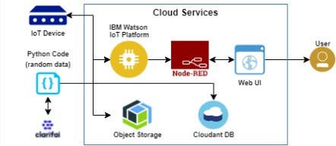

Table-1: Components & Technologies:

|  |  |  |  |
| --- | --- | --- | --- |
| **S.No** | **Component** | **Description** | **Technology** |
| 1. | User Interface | How user interacts with the Web UI | App development |
| 2. | Application Logic-1 | Logic for a process in the application | Python Objectives |
| 3. | Application Logic-2 | Logic for a process in the application | IBM Watson STT service |
| 4. | Application Logic-3 | Logic for a process in the | Node-RED service |

|  |  |  |  |
| --- | --- | --- | --- |
|  |  | application |  |
| 5. | Database | Data Type | Database Cloudant DB |
| 6. | Cloud Database | Database Service on Cloud | Cloud Object store service |
| 7. | File Storage | File storage requirements | IBM Block Storage |
| 8. | Infrastructure (Server / Cloud) | Application Deployment on Local System / Cloud Local Server Configurationo  Cloud Server Configurationo | Cloud Foundry |

|  |  |  |  |
| --- | --- | --- | --- |
| **S.No** | **Characteristics** | **Description** | **Technology** |
| 1. | Open-source Frameworks | The open- source frameworks used | SAN-SAF |
| 2. | Security Implementations | List all the security / access controls implemented | IBM cloud encryptions |
| 3. | Scalable Architecture | Justify the scalability of architecture (3 – tierr  Micro-services) | IBM cloud Architecture |
| 4. | Availability | Justify the availability of applications (e.g. use of load balancersr distributed servers etc.) | Web Application can even be used by the framers in the horticulture |
| 5. | Performance | Design consideration for the performance of the application | Since the web application is high efficientr it can be used by the farmers irrespective of time |